**Code Collab Bot**

At rudimentary level the bot creates and destroys dynamically created voice channels.

Let me elaborate on that…  
  
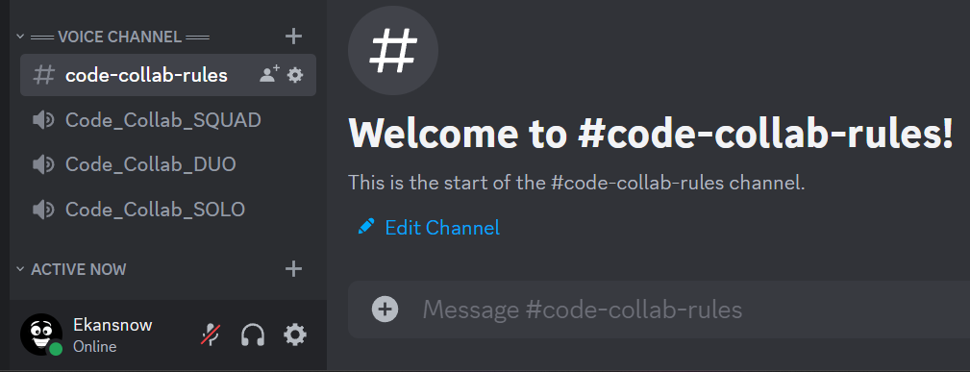

You see there is a category called “---Voice Channel---” which contains one text channel for mentioning rules (how to use this bot) and three voice channels called: -

Code_Collab_SQUAD

Code_Collab_DUO

Code_Collab_SOLO

Here is the interesting part…

*Clicking/Selecting any of these channels doesn’t let you join them, but creates* ***new voice channel*** *with your unique discord user name as the name of the channel and* ***max number of members that can join limited to your choice****.*

Here is an example: -

Me selecting Code_Collab_DUO

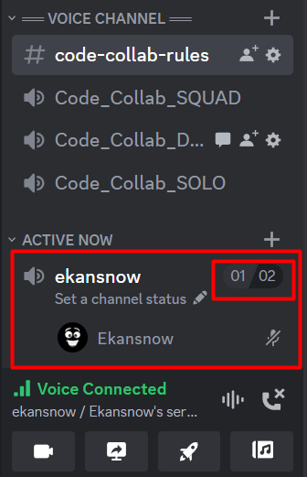

Another member selecting Code_Collab_SQUAD

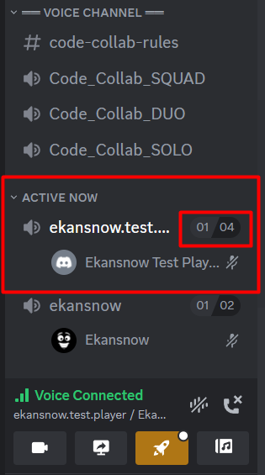

Notice how new channels are created and destroyed within “ACTIVE NOW” section. This will keep the server highly organized.  
Channel destruction happens as soon as the host (member who selected Code Collab voice channel) leaves the channel.

**Applications: -**

The possibilities of application of these features are endless. We can use them in **hackathon, gaming events, code reviews, study partner** etc.  
These would create a great section within the server for individuals to collaborate, leading to added value for community members and beautiful memories.

Rest of the functionality remains the same as that of a voice channel  
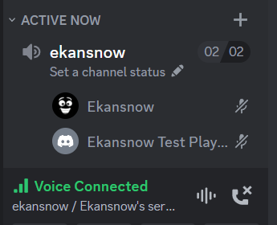 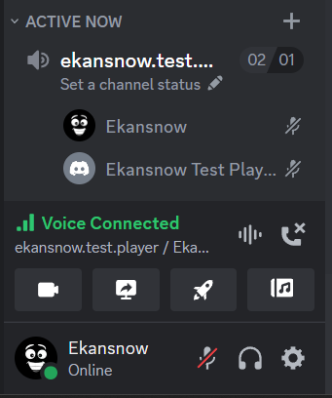

Admins can bypass the maximum number of people allowed to join – “rule”.  
See the image on the right (02/01)  
  
Cool right!....I meant this custom bot – Code Collab Bot.